**AI-Driven Exploration and Prediction of Company Registration Trends with Registrar of companies (RoC)**

**TEAM MEMBER**

**AU620121243004 : BADHRINATHAN.M**

**Phase 2 submission Document**

**Project: AI-Driven Exploration and Prediction of Company Registration Trends with Registrar of companies (RoC)**

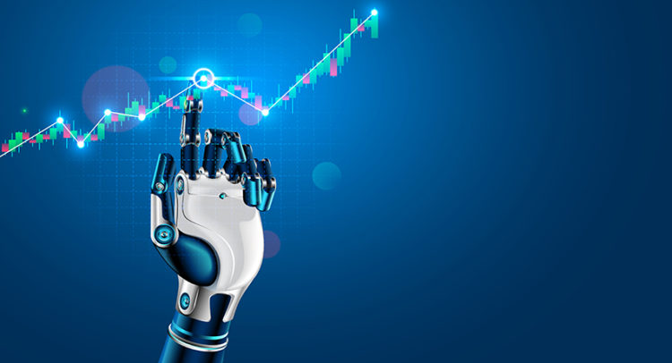

**Introduction:**

* In today's fast-paced business landscape, the Registrar of Companies (RoC) plays a pivotal role in tracking company registrations. With the advent of Artificial Intelligence (AI), companies are now harnessing its power to gain insights, streamline processes, and predict trends related to RoC registrations. This AI-driven approach revolutionizes how businesses interpret and anticipate company registration data, offering valuable insights for informed decision-making and regulatory compliance. In this discussion, we will delve into the exciting realm of AI-driven explanations and predictions of company registration trends with RoC, exploring its significance and potential impact on various industries.
* Certainly, let's delve deeper into the topic of AI-driven explanation and prediction of company registration trends with the Registrar of Companies (RoC):

1. **\*Data Analysis and Insights:\*** AI algorithms are capable of processing vast amounts of historical data from RoC registrations. By analyzing this data, AI can identify patterns, trends, and correlations that might not be immediately apparent to human analysts. This allows businesses and regulatory bodies to gain deeper insights into the dynamics of company registrations.

2. **\*Forecasting Trends:\*** AI can predict future registration trends based on historical data and current market conditions. This forecasting capability is invaluable for businesses to make strategic decisions, such as identifying potential growth areas or anticipating market shifts.

3**. *Compliance and Risk Management:\*** AI can help companies stay compliant with regulatory requirements by flagging discrepancies or anomalies in registration data. This proactive approach reduces the risk of non-compliance and associated penalties.

4. **\*Efficiency and Automation:\*** AI-powered systems can automate many registration-related tasks, reducing administrative burdens. This not only saves time and resources but also minimizes errors in the registration process.

5. **\*Customer Insights:\*** Companies can use AI to analyze registration data to better understand their customer base. This knowledge can inform marketing strategies, product development, and customer relationship management.

6**. *Fraud Detection:\*** AI can detect fraudulent registrations by identifying unusual patterns or discrepancies in registration data. This is crucial for maintaining the integrity of the registration system.

7. **\*Predictive Analytics:\*** AI can provide predictive analytics on factors such as industry-specific registration trends, geographical variations, and economic indicators. This information is valuable for businesses looking to expand or enter new markets.

8. **\*Government and Policy:\*** Governments and regulatory authorities can use AI to monitor economic trends and make data-driven policy decisions. This can lead to more efficient allocation of resources and better economic planning.

9. **\*Investor Confidence:\*** Accurate prediction and explanation of registration trends can boost investor confidence by providing transparent and reliable information about market conditions.

10**. *Challenges:\*** While AI offers immense potential, there are challenges, such as data privacy concerns, the need for high-quality data, and the requirement for skilled AI professionals to develop and maintain these systems.

* In conclusion, AI-driven explanation and prediction of company registration trends with the RoC represent a transformative leap in data analysis and regulatory compliance. The ability to extract meaningful insights, forecast future trends, and enhance efficiency has the potential to revolutionize how businesses and governments interact with registration data, ultimately leading to more informed decisions and improved economic outcomes.

**Content for phase 2:**

We consider as if this AI-Driven prediction has to be performed by the method of “Ensemble Learning” by the corresponding dataset in many company details.

**Data source:**

The datasets consists of several of the company details to predict the following of company registration trends in the outcome of the following no of company details are there in the dataset by their companynames, status, registration, state these all are included.

**Dataset link: (**[**https://www.kaggle.com/datasets/rowhitswami/all-indian-companies-registration-data-1900-2019**](https://www.kaggle.com/datasets/rowhitswami/all-indian-companies-registration-data-1900-2019)**)**

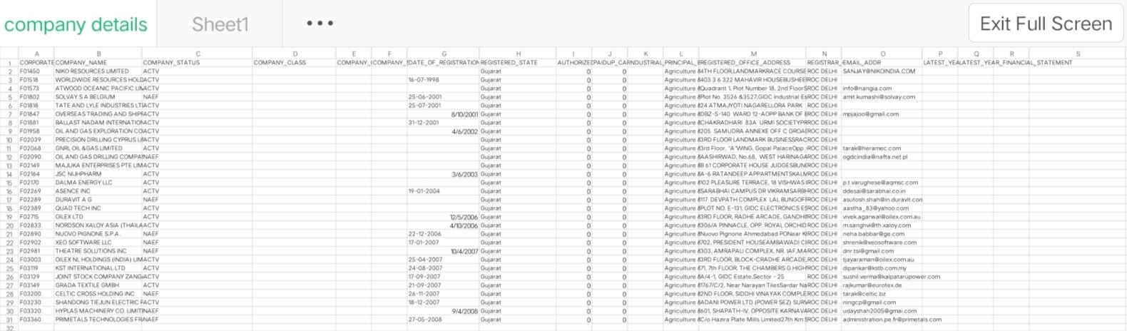

**Steps involved in AI-Driven Company Trends (RoC):**

1. **\*Data Collection*:** Gather historical financial data for the company, including variables like revenue, expenses, assets, and liabilities. You might also want to include external factors like economic indicators, industry trends, or competitor performance.

2. **\*Data Cleaning*:** Clean the data to handle missing values, outliers, and inconsistencies. This step is crucial as the quality of your data directly impacts the accuracy of your prediction.

3. **\*Exploratory Data Analysis (EDA)*:** Perform EDA to gain insights into the data. This includes:

- **\*Descriptive Statistics*:** Calculate summary statistics like mean, median, and standard deviation.

**- *Data Visualization*:** Create plots and charts (e.g., time series plots, histograms, scatter plots) to visualize the data's distribution and patterns.

**- *Correlation Analysis*:** Determine relationships between variables using correlation matrices to understand which factors might impact ROC.

4. **\*Feature Engineering*:** Create new features or transform existing ones to better represent the relationships in your data. For example, you could calculate financial ratios or moving average.

5. **\*Model Selection*:** Choose an appropriate machine learning or statistical model for predicting ROC. Common models for time series data include ARIMA, LSTM, or even regression models.

6. **\*Data Splitting*:** Split your data into training and testing sets to evaluate the model's performance accurately.

7. **\*Model Training*:** Train the chosen model using the training data, considering appropriate hyperparameters.

8. **\*Model Evaluation*:** Evaluate the model's performance on the testing data using metrics like Mean Absolute Error (MAE), Mean Squared Error (MSE), or Root Mean Squared Error (RMSE).

9. **\*Model Interpretation*:** Analyze the model's coefficients or feature importances to understand which variables are most influential in predicting ROC trends.

10. **\*Deployment and Monitoring*:** If the model performs well, deploy it to make predictions for future data. Continuously monitor the model's performance and retrain it as needed.

Remember that predicting financial trends is a complex task, and the accuracy of your prediction will depend on the quality and relevance of the data you have and the model you choose. Additionally, consider external factors like economic events or changes in company strategy that can impact ROC.

**Exploring the Data:**

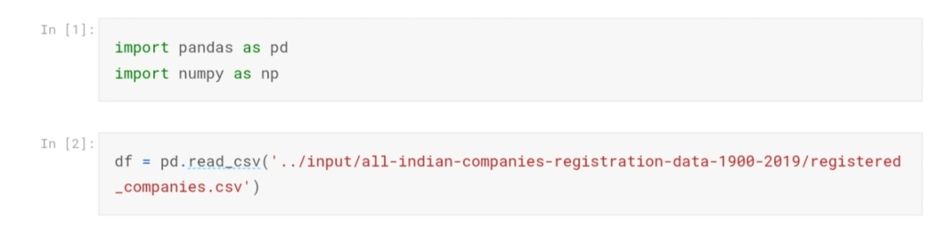

The corresponding libraries are imported.

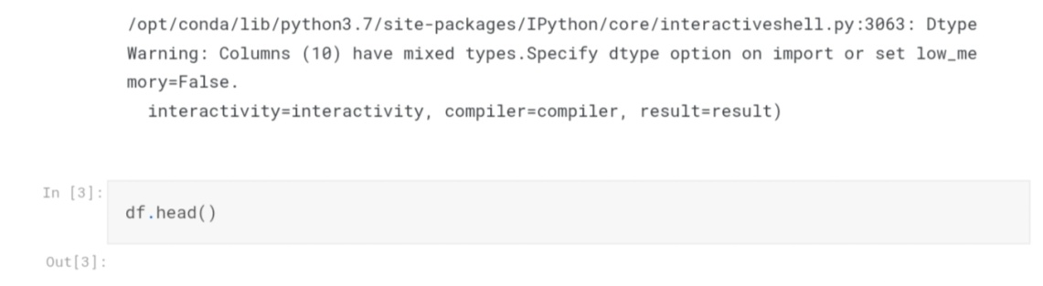

#to get the number of columns by the following dataset in the corresponded company-RoC driven data.

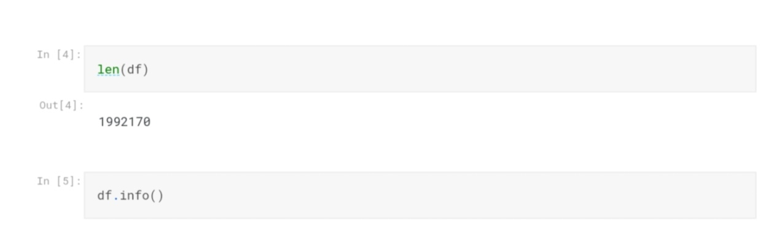

The datasets consists of several of the company details to predict the following of company registration trends in the outcome of the following no of company details are there in the dataset by their companynames, status, registration, state these all are included.

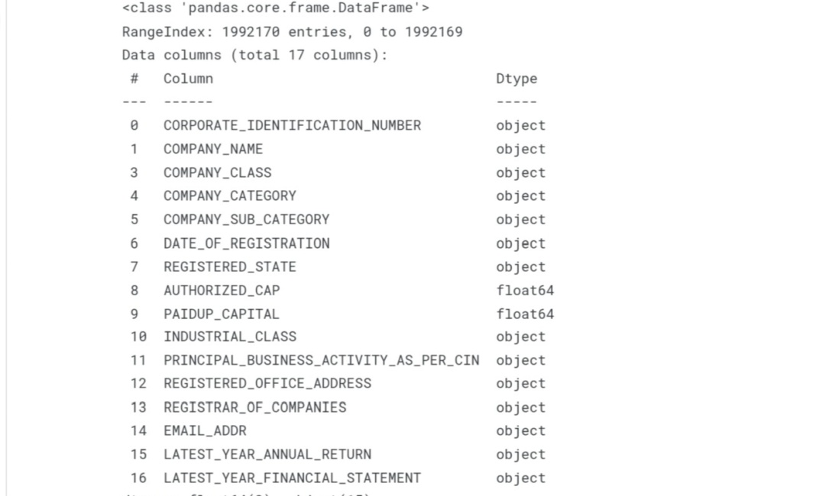

**Output:**

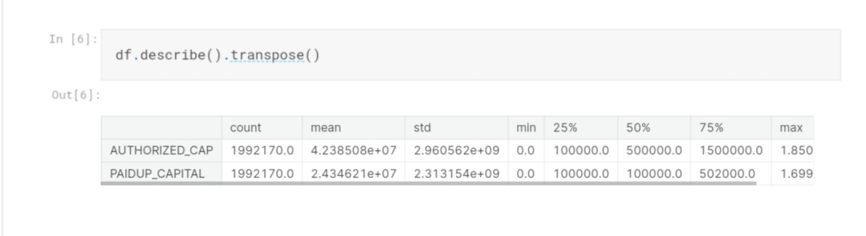



In this clear column has to represent the following detail about the company RoC by the assumption of 35 company details.

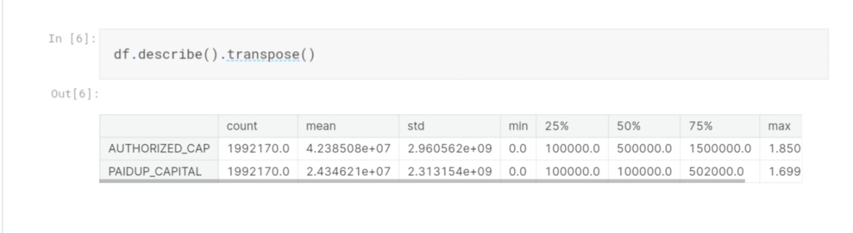

In this output value has 1 means the following company to goes the range of prediction as the higher same as the output value has 0 means the prediction can lower in the trends.

**Regression:**

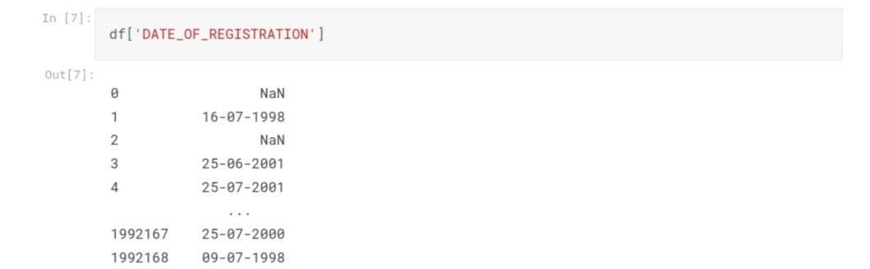

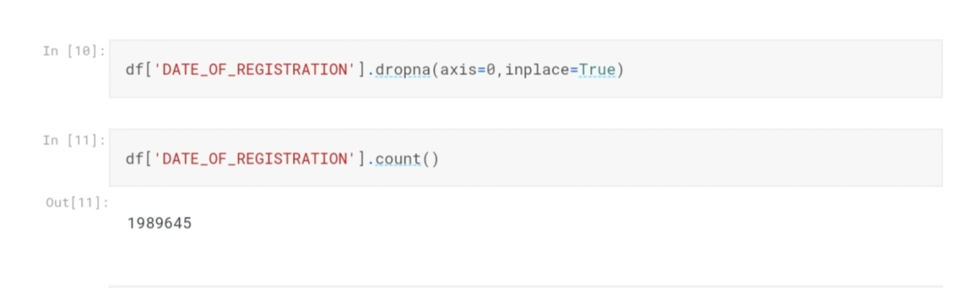

In the next stage of process has to be used for the regression in machine learning model that the Exploratory Data Analysis can be performed.

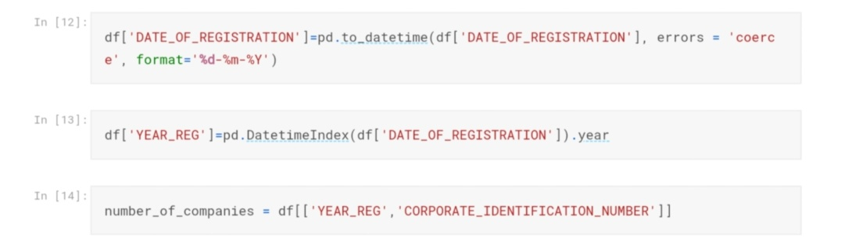

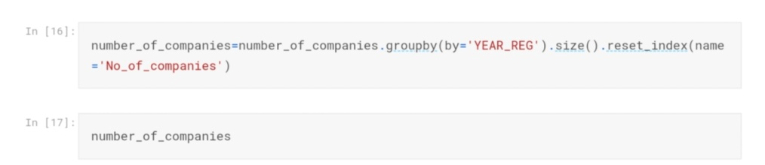

**Output:**

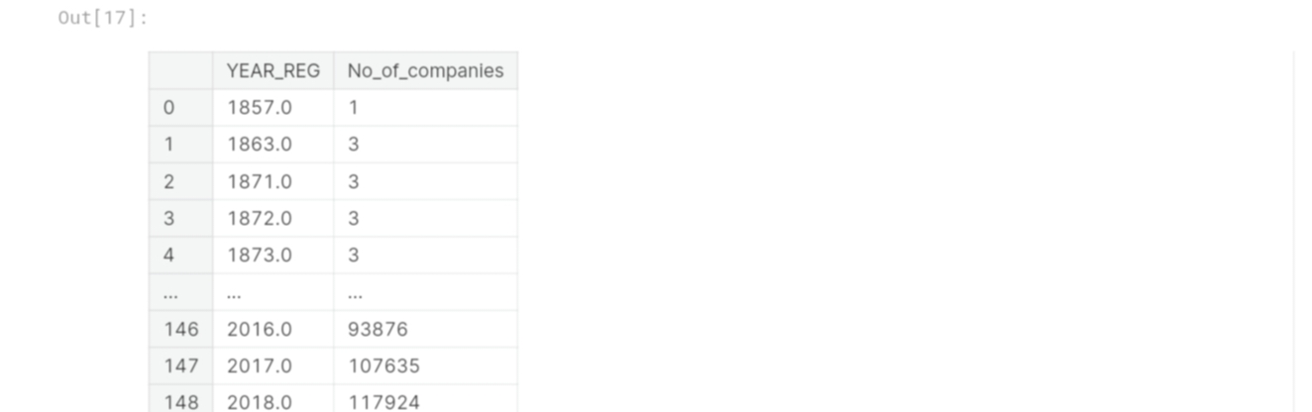

**Import Mathplotlib:**

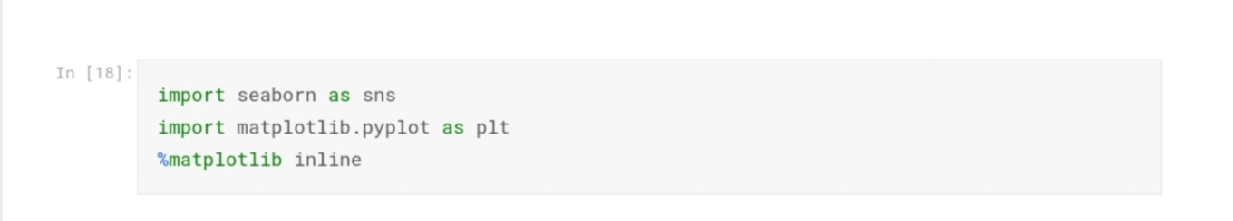

In this mathplotlib is used to show our predicted output in a graph.

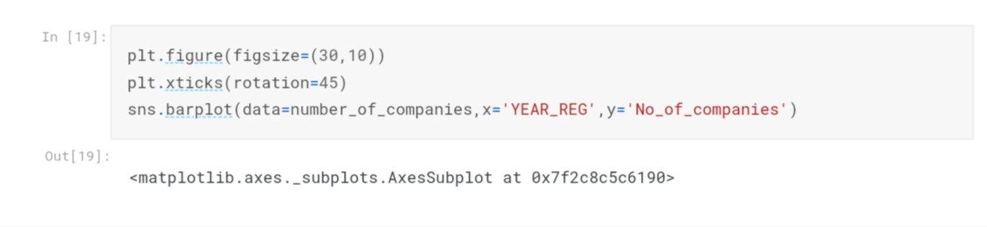

In this following output as,

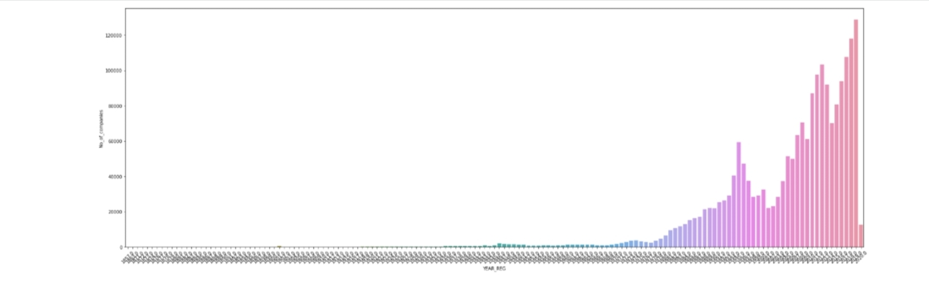

**Training model:**

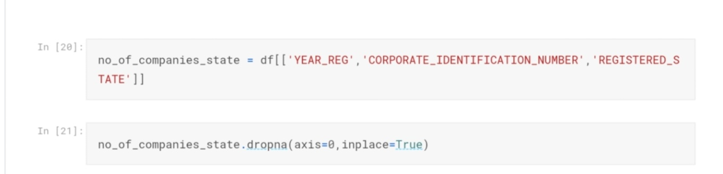

It measures the year of register in the company (RoC).

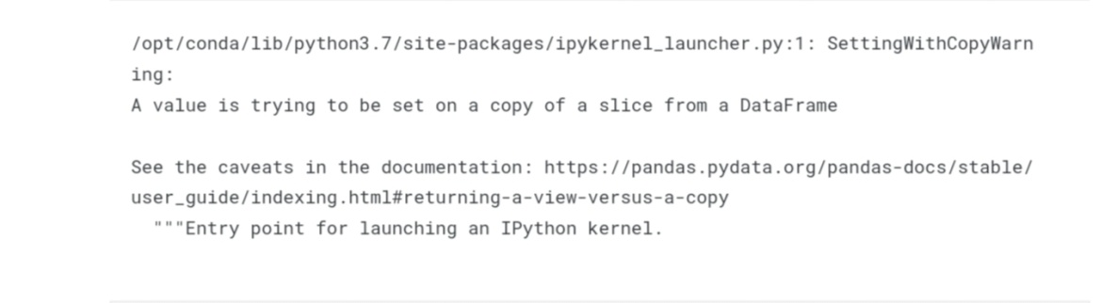

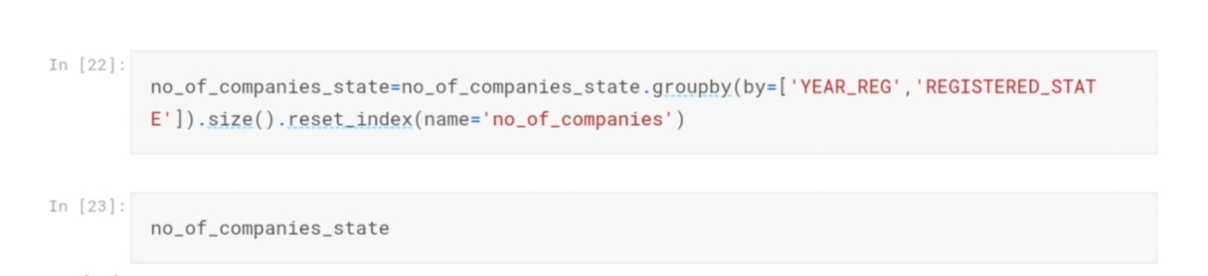

**Output:**

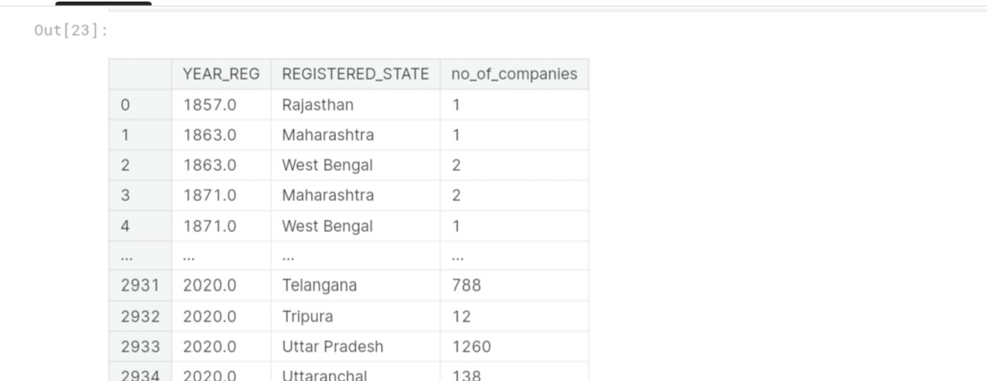

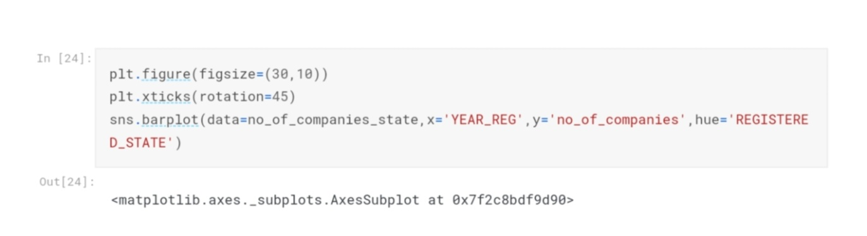

**Output Graph:**

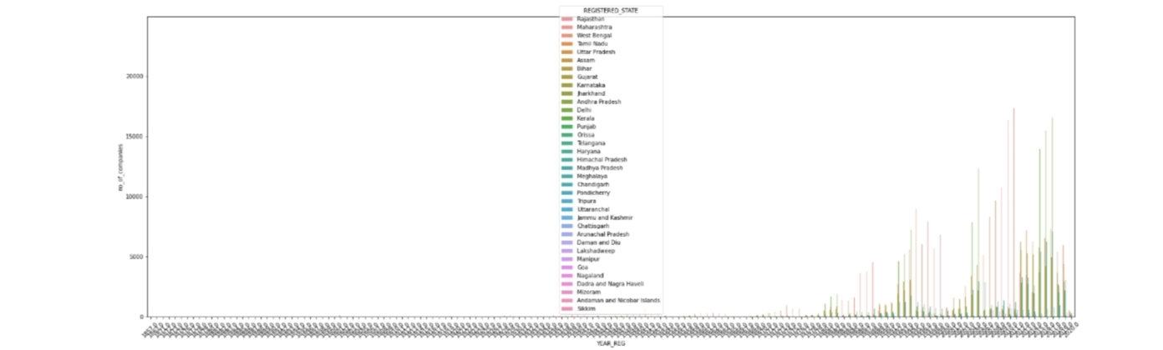

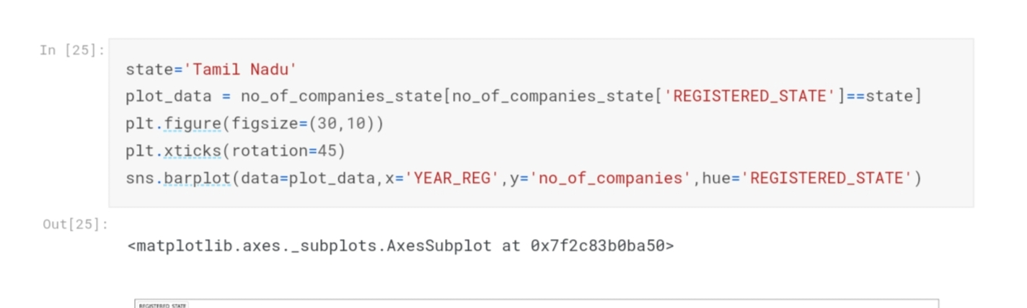

In this plot can be the following “TamilNadu” to the registered state of the company RoC.

**Output Plot:**

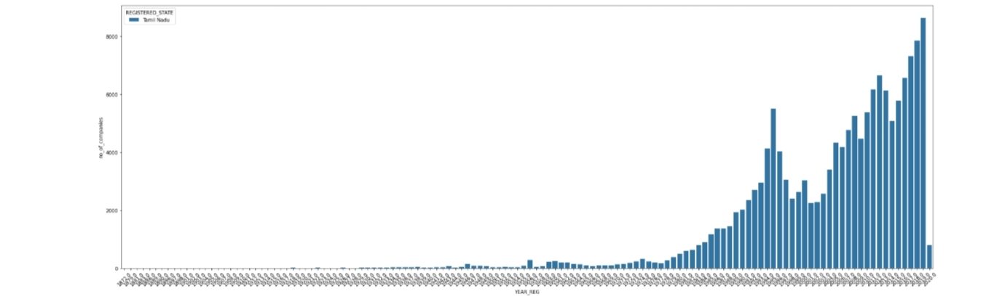

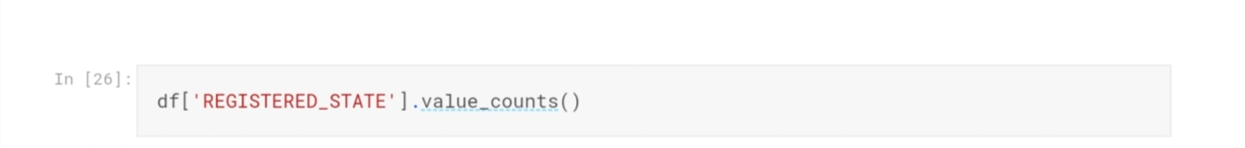

In this case the following data’s of all states as,

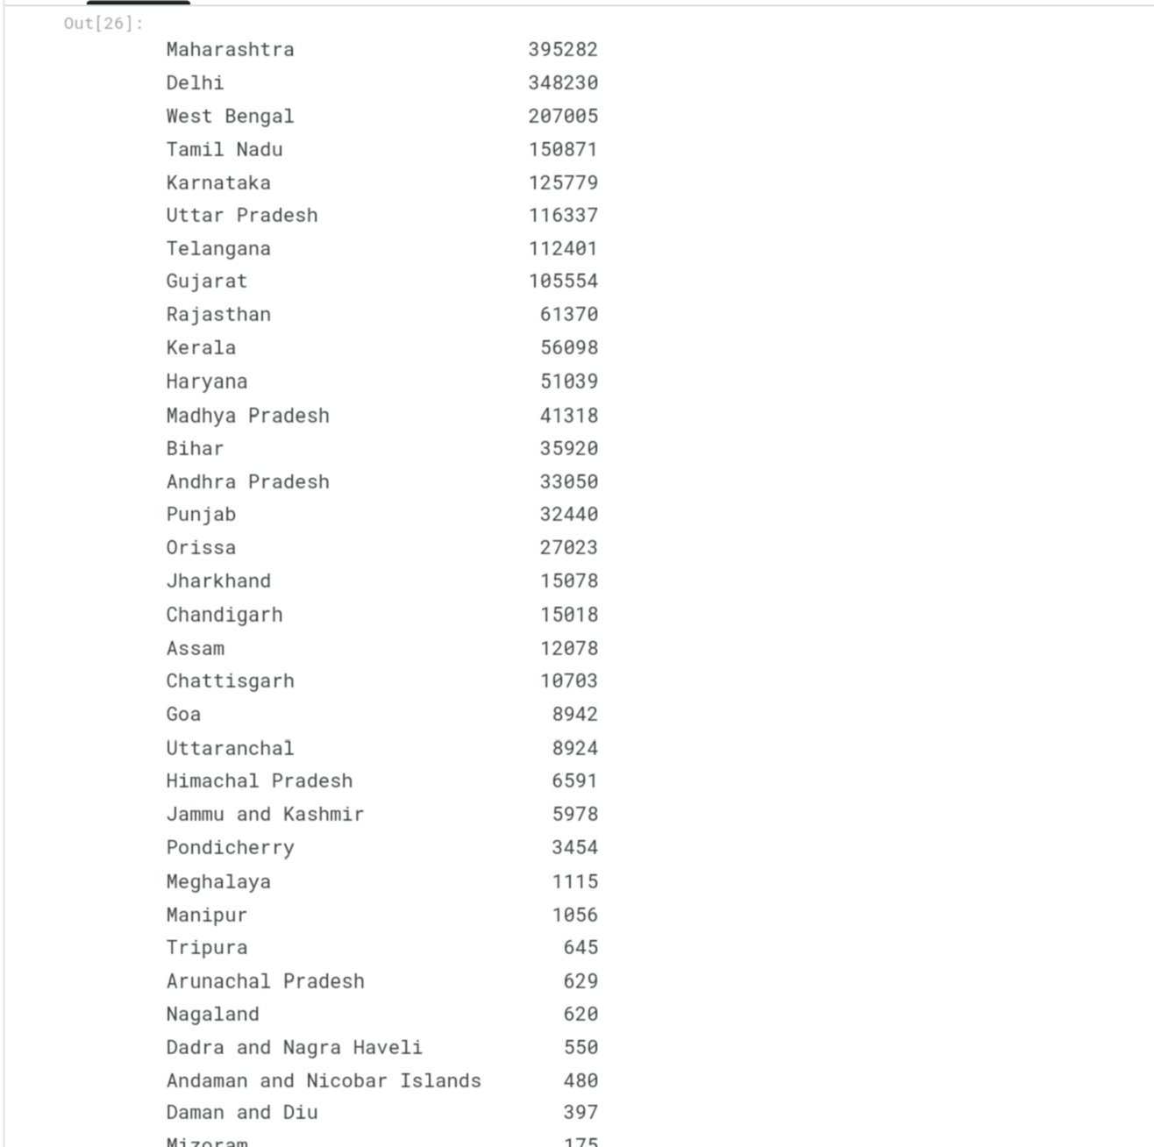

**The ploted place in types of companies:**

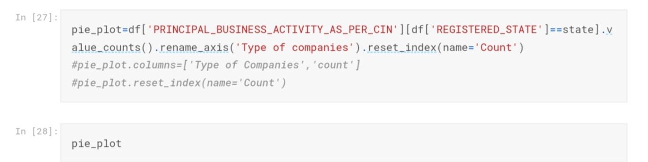

Types of companies in all the states:

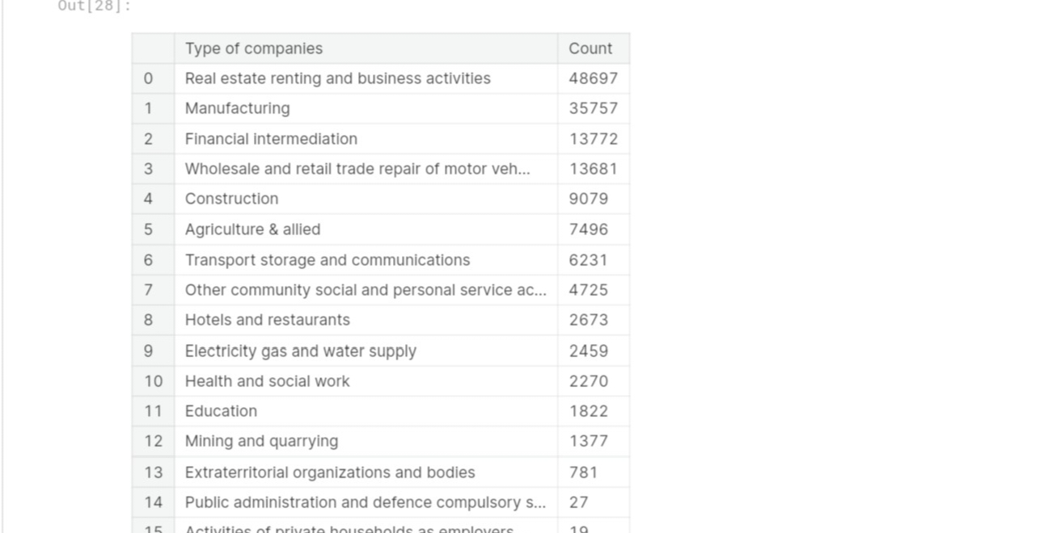

Pie chat calculation for the above companies:

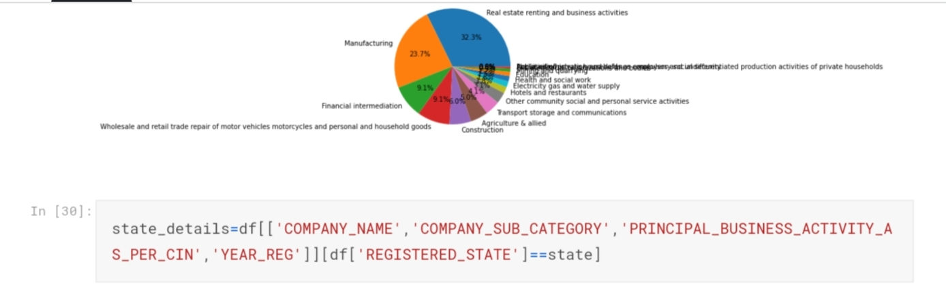

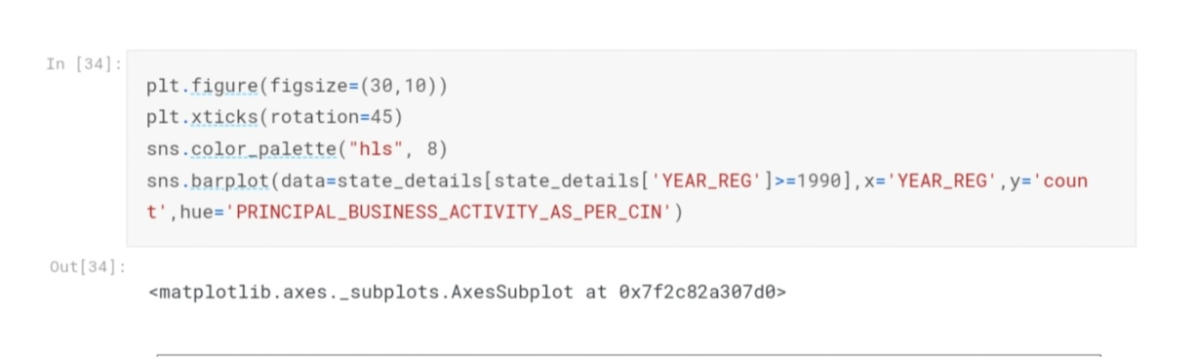

**The output Predicted company trends:**

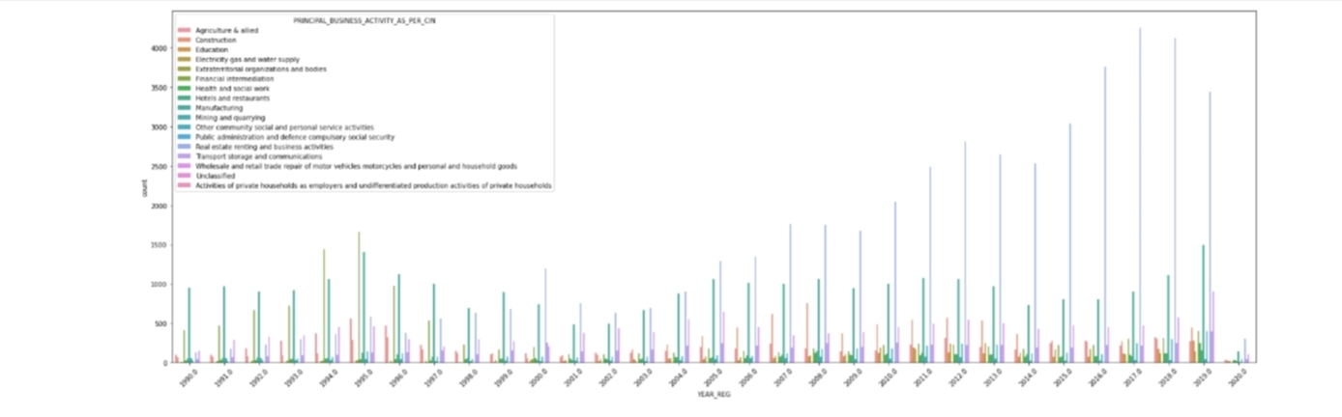

**CONCLUSION:**

1.In the Phase 2 conclusion, we will summarize the findings and insights from the

advanced regression techniques. We will reiterate the impact of these techniques on

improving the AI-Driven Exploration and Prediction of Company Registration Trends with Registrar of companies (RoC).

Future Work: We will discuss potential avenues for future work, such as incorporating

additional data sources (e.g., real-time economic indicators), exploring deep learning models

for prediction, or expanding the project into a web application with more features and

interactivity.